**Personal Portfolio**

106

Alexander Rozsa – n9992529

<https://github.com/Azsorlex26/IFB299-Vroom-x3-Car-Rentals>

**Artefact 1** – Customer Personal History Mockup

(Description about what the artefact is in general)

I created this mockup to lay out how the customer personal history page should be implemented. Instead of having it on its own page, I planned to have it implemented on the existing rental history page, and have it change content depending on the role of the user logged in.

(Brief description of how it was used/contribution to the project)

For the development of visual design of the customer personal history interface.

(Screen capture of where it’s used)

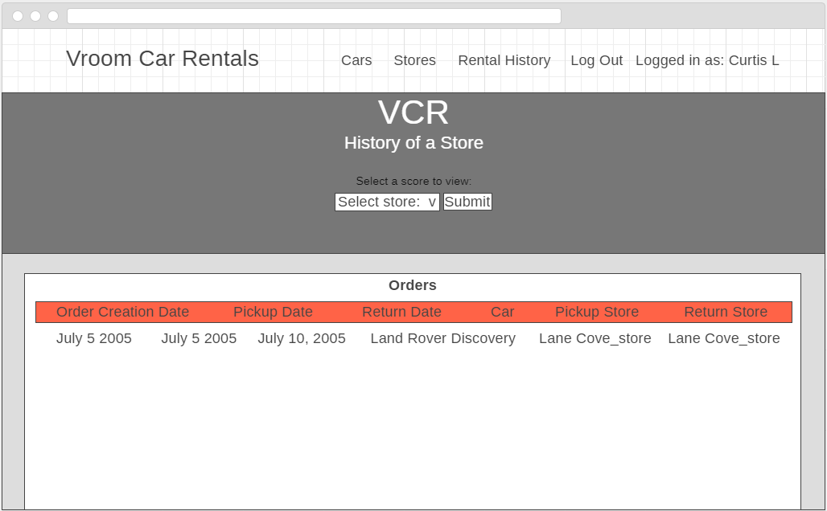

**Artefact 2** – Customer Personal History Page (views.py code)

The customer personal history story required a separate page to be implemented for a customer to view their personal rental history (if logged in). I implemented it in such a way that a new page wasn’t required. Instead, the existing rental history page for staff was used, which gets updated depending on the user logged in. The function already existed, but I updated it in such a way that allowed the tables to be produced using a for loop instead of doubling up on code (see below).

(Brief description of how it was used/contribution to the project)

For the development of the site/completion of a story.

(Screen capture of where it’s used)

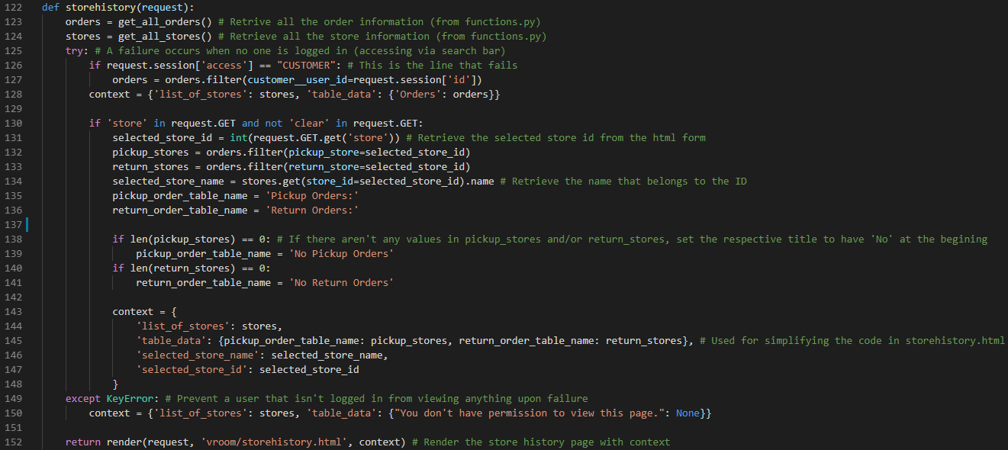

**Artefact 3** – Customer Personal History Page (storehistory.html code)

(Description about what the artefact is in general)

The second part of the above artefact. Again, this page and the general structure for the staff to view customer orders were already in place, however, I modified it to also view customer rental history if a customer is logged in, and all customers’ orders if a staff member is logged in.

(Brief description of how it was used/contribution to the project)

For the development of the site/completion of a story.

(Screen capture of where it’s used)

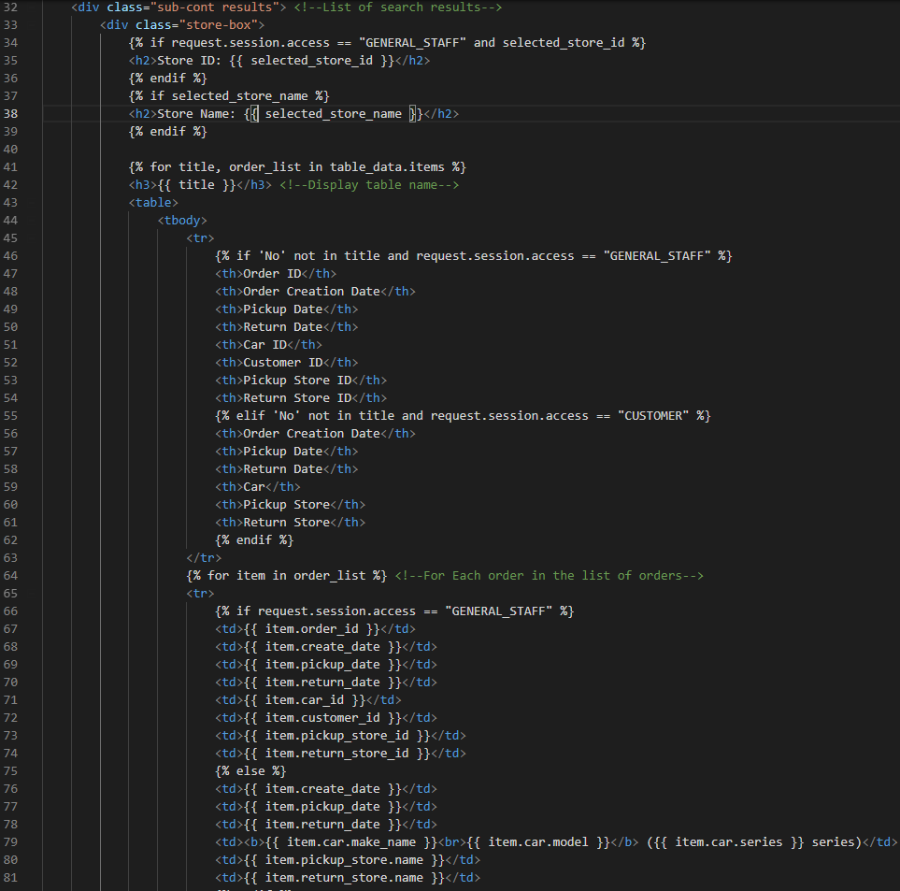

**Artefact 4** – Store History Test

(Description about what the artefact is in general)

This is a physical test that was conducted throughout the development of the rental history page that ensures everything about it is in working order.

(Brief description of how it was used/contribution to the project)

To validate the functionality of the Story History page.

(Screen capture of where it’s used)

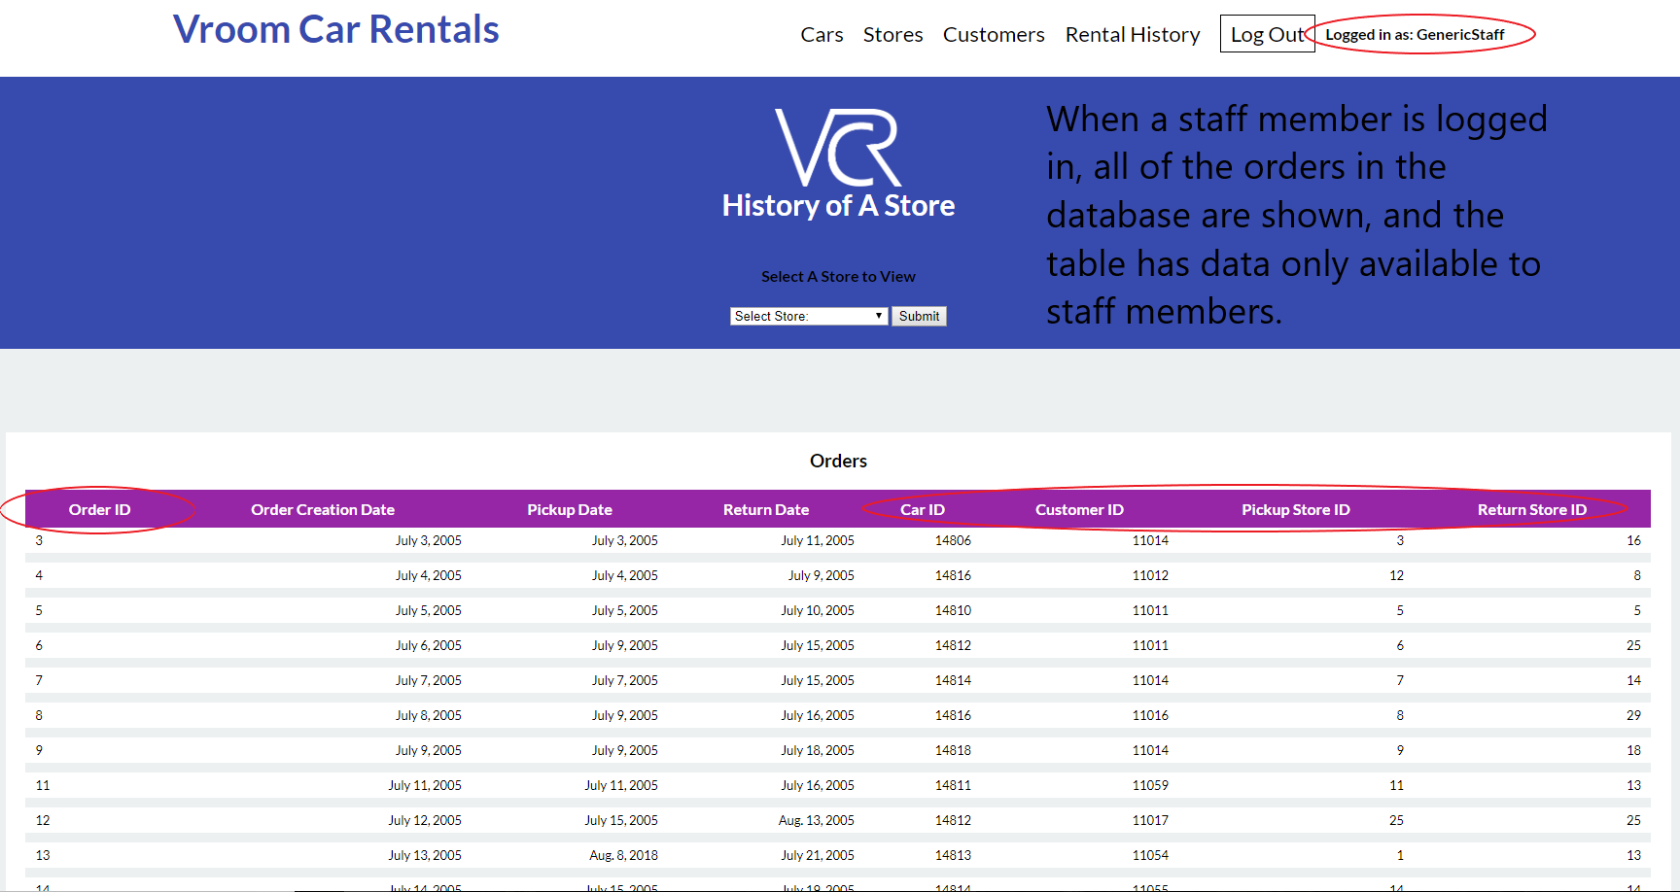

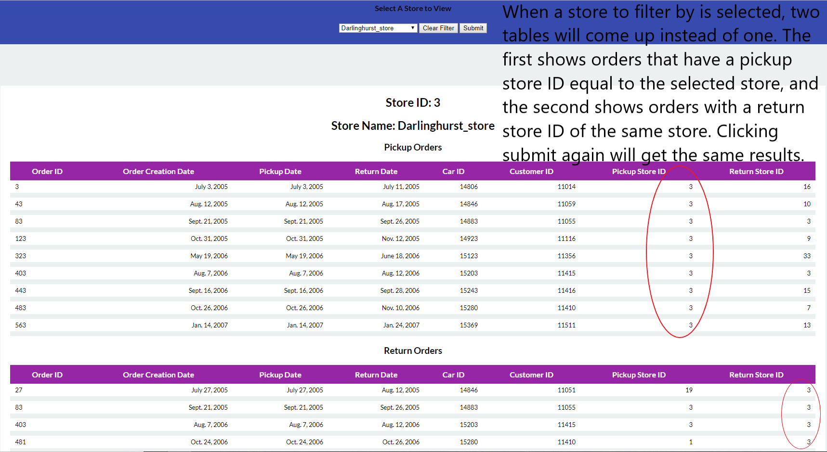

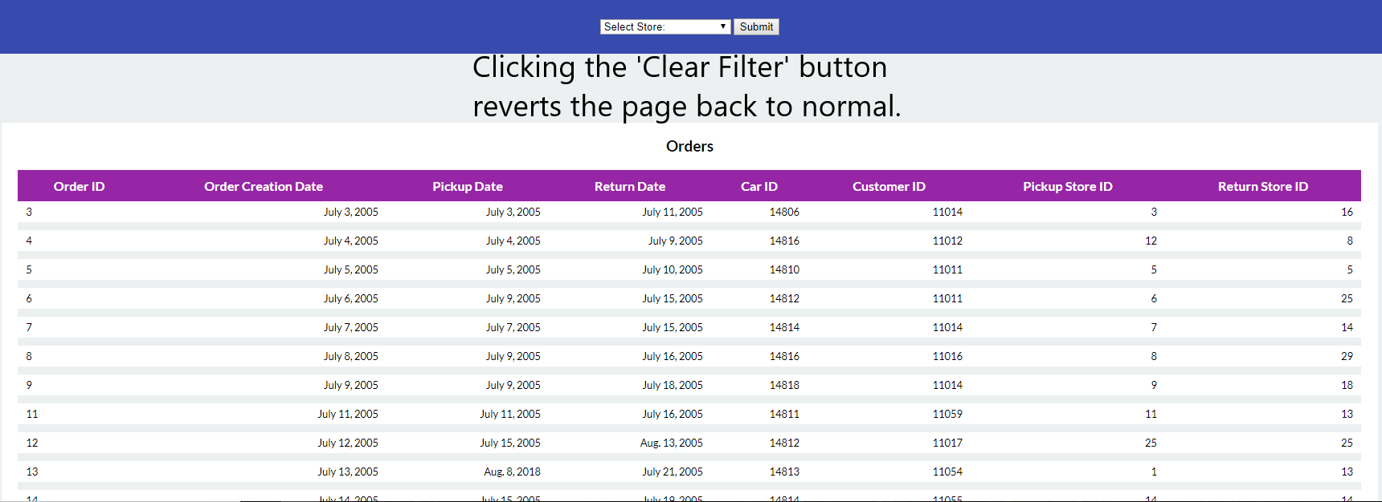

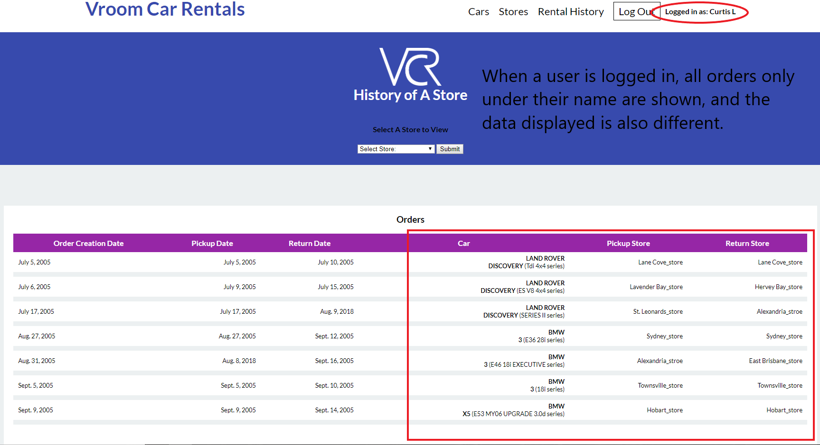

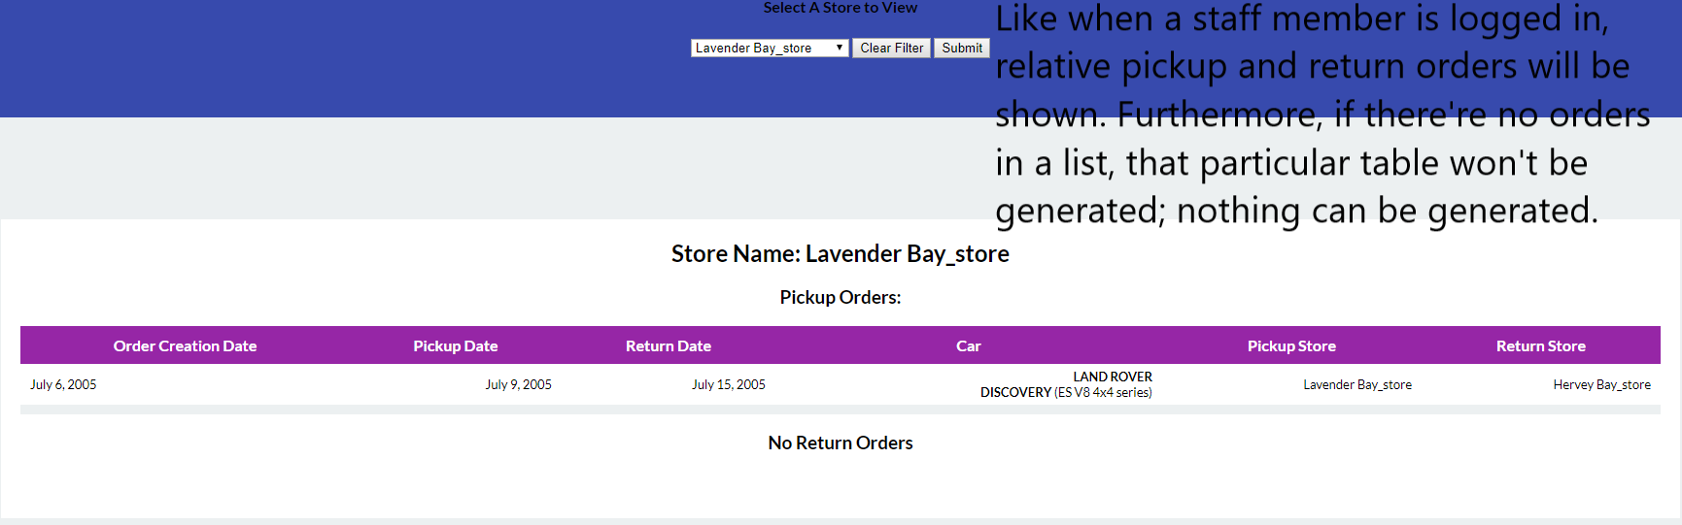

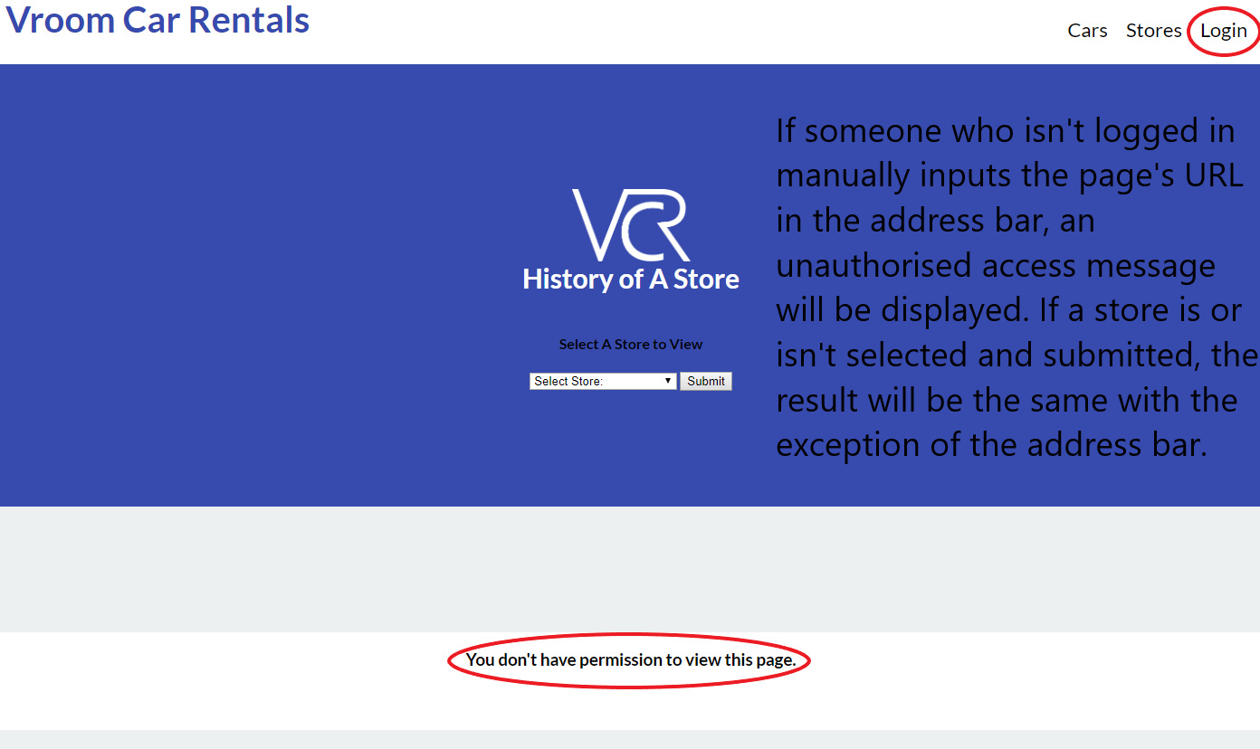

**Artefact 5** – Code Refactoring

(Description about what the artefact is in general)

This artefact involved me going around the coding files and optimising the structure of certain operations to reduce clutter and make them more efficient and/or more readable. This only includes segments of other peoples’ code and not my own. While there might be a small bit of code I wrote, the majority of of it was written by others.

(Brief description of how it was used/contribution to the project)

To try and optimise the project’s code as best as possible.

(Screen capture of where it’s used)

In the following screenshots, left (red) is before and right (green) is after.

**In views .py**

Here, a list of stores was being iterated though until the store selected by the page’s dropdown was found.

Before:

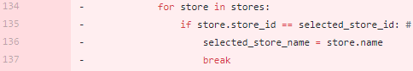

After:



Before:

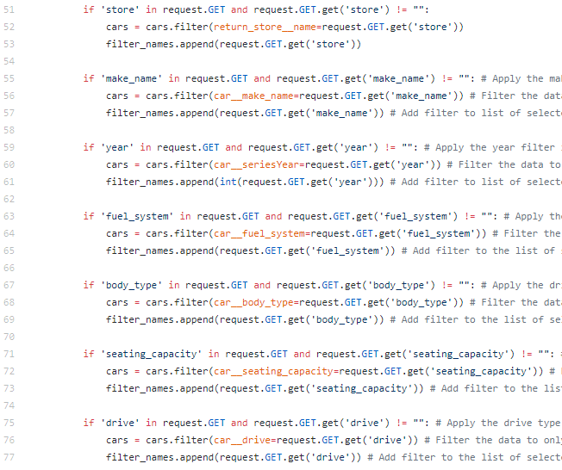

After:

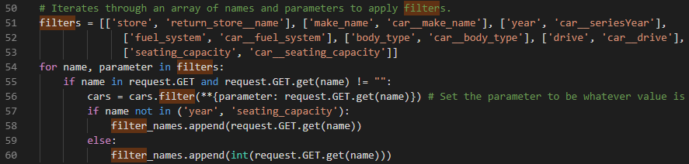

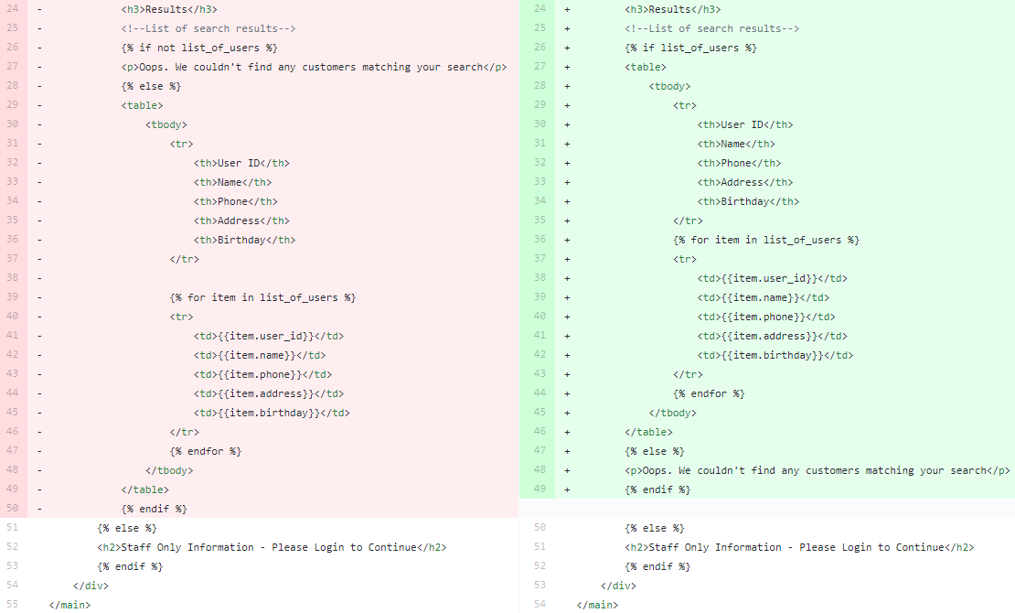**In viewcustomers.html**